### **Assignment 1: Difference between scrum vs Kanban**

### **Scrum:**

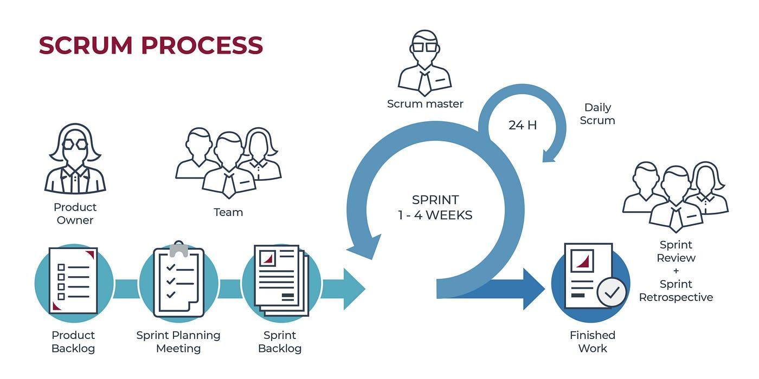

1. **Framework:**
   * **Structure:** Follows a structured framework with specific roles, events, and artifacts.
   * **Sprints:** Work is divided into fixed-length iterations called sprints (typically 2-4 weeks).
2. **Roles:**
   * **Defined Roles:** Includes specific roles such as Product Owner, Scrum Master, and Development Team.
3. **Events:**
   * **Regular Ceremonies:** Involves regular events like Sprint Planning, Daily Stand-ups, Sprint Review, and Sprint Retrospective.
4. **Planning:**
   * **Sprint Planning:** Work is planned at the beginning of each sprint, and the team commits to completing it within the sprint.
5. **Flexibility:**
   * **Fixed Scope:** Scope changes are discouraged during a sprint to maintain focus and predictability.
6. **Metrics:**
   * **Velocity:** Measures the amount of work completed in each sprint to forecast future work.
   * **Burndown Charts:** Tracks progress of tasks against the sprint timeline.

### **Kanban:**

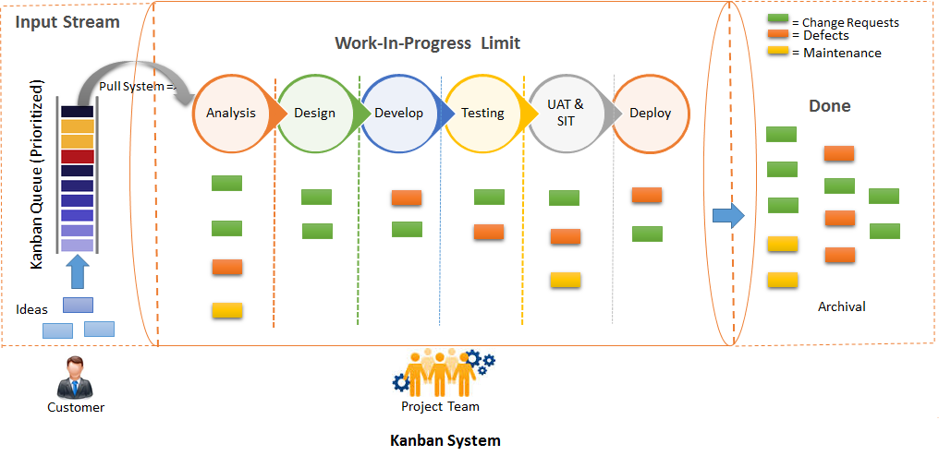

1. **Framework:**
   * **Flexible:** A visual method to manage work that emphasizes continuous delivery without prescribed roles or timeframes.
   * **Continuous Flow:** Tasks are added and completed continuously without fixed-length iterations.
2. **Roles:**
   * **No Prescribed Roles:** Works with existing team roles and does not define specific roles.
3. **Events:**
   * **As Needed:** Does not have prescribed regular events but may use meetings as needed for coordination.
4. **Planning:**
   * **Continuous Planning:** Tasks are planned and prioritized continuously based on current needs and capacity.
5. **Flexibility:**
   * **Dynamic Scope:** Allows for more flexibility in reprioritizing tasks at any time.
6. **Metrics:**
   * **Lead Time and Cycle Time:** Focuses on metrics like lead time (time from task creation to completion) and cycle time (time from starting work to task completion).
   * **Cumulative Flow Diagram:** Visualizes the flow of tasks to identify bottlenecks and improve process efficiency.

### **Key Differences:**

* **Iteration vs. Flow:** Scrum uses fixed-length sprints, while Kanban uses a continuous flow.
* **Roles:** Scrum has specific roles (Product Owner, Scrum Master, Development Team); Kanban does not prescribe roles.
* **Events:** Scrum has regular, structured events; Kanban uses meetings as needed.
* **Scope Changes:** Scrum discourages changes during a sprint; Kanban allows for continuous reprioritization.
* **Planning:** Scrum plans at the start of each sprint; Kanban involves continuous planning.
* **Metrics:** Scrum focuses on velocity and burndown charts; Kanban focuses on lead time, cycle time, and cumulative flow.

In summary, **Scrum** provides a structured approach with defined roles and regular intervals, making it ideal for projects with clear goals and stable requirements within each sprint. **Kanban** offers more flexibility and is well-suited for environments with continuous flow of work and frequently changing priorities.